SOFTWARE ENGINEERING
INTRODUCTION.
Software is a program or set of programs containing instructions that provide the desired functionality. Engineering is the process of designing and building something that serves a particular purpose and finds a cost-effective solution to problems.
Software Engineering is the process of designing, developing, testing, and maintaining software.
- Software engineering includes a variety of techniques, tools, and methodologies, including requirements analysis, design, testing, and maintenance.
- It is a rapidly evolving field, and new tools and technologies are constantly being developed to improve the software development process.
- By following the principles of software engineering and using the appropriate tools and methodologies, software developers can create high-quality, reliable, and maintainable software that meets the needs of its users.
- Software Engineering is mainly used for large projects based on software systems rather than single programs or applications.
- The main goal of Software Engineering is to develop software applications for improving quality, budget, and time efficiency.
- bSoftware Engineering ensures that the software that has to be built should be consistent, correct, also on budget, on time, and within the required requirements.

Key Principles of Software Engineering
- Modularity: Breaking the software into smaller, reusable components that can be developed and tested independently.
- Abstraction: Hiding the implementation details of a component and exposing only the necessary functionality to other parts of the software.
- Encapsulation: Wrapping up the data and functions of an object into a single unit, and protecting the internal state of an object from external modifications.
- Reusability: Creating components that can be used in multiple projects, which can save time and resources.
- Maintenance: Regularly updating and improving the software to fix bugs, add new features, and address security vulnerabilities.
- Testing: Verifying that the software meets its requirements and is free of bugs.
- Design Patterns: Solving recurring problems in software design by providing templates for solving them.
- Agile methodologies: Using iterative and incremental development processes that focus on customer satisfaction, rapid delivery, and flexibility.
- Continuous Integration & Deployment: Continuously integrating the code changes and deploying them into the production environment.

Main Attributes of Software Engineering
Software Engineering is a systematic, disciplined, quantifiable study and approach to the design, development, operation, and maintenance of a software system. There are four main Attributes of Software Engineering.
- Efficiency: It provides a measure of the resource requirement of a software product efficiently.
- Reliability: It assures that the product will deliver the same results when used in similar working environment.
- Reusability: This attribute makes sure that the module can be used in multiple applications.
- Maintainability: It is the ability of the software to be modified, repaired, or enhanced easily with changing requirements.

Dual Role of Software
There is a dual role of software in the industry. The first one is as a product and the other one is as a vehicle for delivering the product. We will discuss both of them.

1. As a Product
- It delivers computing potential across networks of Hardware.
- It enables the Hardware to deliver the expected functionality.
- It acts as an information transformer because it produces, manages, acquires, modifies, displays, or transmits information.

2. As a Vehicle for Delivering a Product
- It provides system functionality (e.g., payroll system).
- It controls other software (e.g., an operating system).
- It helps build other software (e.g., software tools).

Objectives of Software Engineering
- Maintainability: It should be feasible for the software to evolve to meet changing requirements.
- Efficiency: The software should not make wasteful use of computing devices such as memory, processor cycles, etc.
- Correctness: A software product is correct if the different requirements specified in the SRS Document hav e been correctly implemented.
- Reusability: A software product has good reusability if the different modules of the product can easily be reused to develop new products.
- Testability: Here software facilitates both the establishment of test criteria and the evaluation of the software concerning those criteria.
- Reliability: It is an attribute of software quality. The extent to which a program can be expected to perform its desired function, over an arbitrary time period.
- Portability: In this case, the software can be transferred from one computer system or environment to another.
- Adaptability: In this case, the software allows differing system constraints and the user needs to be satisfied by making changes to the software.
- Interoperability: Capability of 2 or more functional units to process data cooperatively.

Program vs Software Product
Parameters | Program | Software Product
Definition | A program is a set of instructions that are given to a computer in order to achieve a specific task. | Software is when a program is made available for commercial business and is properly documented along with its licensing.  Software Product = Program + Documentation + Licensing.
Stages Involved | Program is one of the stages involved in the development of the software. | Software Development usually follows a life cycle, which involves the feasibility study of the project, requirement gathering, development of a prototype, system design, coding, and testing.

Classification of Software
The software can be classified based on various criteria, including:
- Purpose: Software can be classified as system software (e.g., operating systems, device drivers) or application software (e.g., word processors, games).
- Platform: Software can be classified as native software (designed for a specific operating system) or cross-platform software (designed to run on multiple operating systems).
- Deployment: Software can be classified as installed software (installed on the user's device) or cloud-based software (hosted on remote servers and accessed via the internet).
- License: Software can be classified as proprietary software (owned by a single entity) or open-source software (available for free with the source code accessible to the public).
- Development Model: Software can be classified as traditional software (developed using a waterfall model) or agile software (developed using an iterative and adaptive approach).
- Size: Software can be classified as small-scale software (designed for a single user or small group) or enterprise software (designed for large organizations).
- User Interface: Software can be classified as Graphical User Interface (GUI) software or Command-Line Interface (CLI) software.

Software Evolution.
Software Evolution is a term that refers to the process of developing software initially, and then timely updating it for various reasons, i.e., to add new features or to remove obsolete functionalities, etc. This article focuses on discussing Software Evolution in detail.

What is Software Evolution?
The software evolution process includes fundamental activities of change analysis, release planning, system implementation, and releasing a system to customers.
- The cost and impact of these changes are accessed to see how much the system is affected by the change and how much it might cost to implement the change.
- If the proposed changes are accepted, a new release of the software system is planned.
- During release planning, all the proposed changes (fault repair, adaptation, and new functionality) are considered.
- A design is then made on which changes to implement in the next version of the system.
- The process of change implementation is an iteration of the development process where the revisions to the system are designed, implemented, and tested.

Necessity of Software Evolution
Software evaluation is necessary just because of the following reasons:
- Change in requirement with time: With time, the organization's needs and modus Operandi of working could substantially be changed so in this frequently changing time the tools(software) that they are using need to change to maximize the performance.
- Environment change: As the working environment changes the things(tools) that enable us to work in that environment also changes proportionally same happens in the software world as the working environment changes then, the organizations require reintroduction of old software with updated features and functionality to adapt the new environment.
- Errors and bugs: As the age of the deployed software within an organization increases their preciseness or impeccability decrease and the efficiency to bear the increasing complexity workload also continually degrades. So, in that case, it becomes necessary to avoid use of obsolete and aged software. All such obsolete Pieces of software need to undergo the evolution process in order to become robust as per the workload complexity of the current environment.
- Security risks: Using outdated software within an organization may lead you to at the verge of various software-based cyberattacks and could expose your confidential data illegally associated with the software that is in use. So, it becomes necessary to avoid such security breaches through regular assessment of the security patches/modules are used within the software. If the software isn't robust enough to bear the current occurring Cyber attacks so it must be changed (updated).
- For having new functionality and features: In order to increase the performance and fast data processing and other functionalities, an organization need to continuously evolute the software throughout its life cycle so that stakeholders & clients of the product could work efficiently.

Laws used for Software Evolution

1. Law of Continuing Change
This law states that any software system that represents some real-world reality undergoes continuous change or become progressively less useful in that environment.

2. Law of Increasing Complexity
As an evolving program changes, its structure becomes more complex unless effective efforts are made to avoid this phenomenon.

3. Law of Conservation of Organization Stability
Over the lifetime of a program, the rate of development of that program is approximately constant and independent of the resource devoted to system development.

4. Law of Conservation of Familiarity
This law states that during the active lifetime of the program, changes made in the successive release are almost constant.

What is the Need of Software Engineering?
- Handling Big Projects: A corporation must use a software engineering methodology in order to handle large projects without any issues.
- To manage the cost: Software engineering programmers plan everything and reduce all those things that are not required.
- To decrease time: It will save a lot of time if you are developing software using a software engineering technique.
- Reliable software: It is the company's responsibility to deliver software products on schedule and to address any defects that may exist.
- Effectiveness: Effectiveness results from things being created in accordance with the standards.
- Reduces complexity: Large challenges are broken down into smaller ones and solved one at a time in software engineering. Individual solutions are found for each of these issues.
- Productivity: Because it contains testing systems at every level, proper care is done to maintain software productivity.

Roles and Responsibilities of Software Engineers
The major role includes working on engineering principles for software development and making modifications to an ongoing project (in terms of architecture, design, or testing), testing also includes UAT (user acceptance testing). Besides this, the major role of a software engineer rotates around system and application development.
That was a brief about the roles of a software engineer, now let’s check and see some of the major highlights in terms of their responsibilities.
- Should be able to develop solutions by gathering information, feedback from users, the case study of system flow, and overall processes
- Able to develop information systems by developing, designing, maintaining, and installing software solutions.
- Should be familiar with SDLC (Software Development Life Cycle)
- Should be able to deliver documentation and demonstrate different solutions for developing flowcharts, code comments, and layouts.
- Deliver and meet the standards for engineering structures and handle complexity to maintain the flow
- Maintain the privacy of confidential pieces related to any project

UNIT TWO

Software Development Life Cycle (SDLC)
Software Development Life Cycle (SDLC) is a structured process that is used to design, develop, and test high-quality software. SDLC, or software development life cycle, is a methodology that defines the entire procedure of software development step-by-step. The goal of the SDLC life cycle model is to deliver high-quality, maintainable software that meets the user's requirements.
SDLC in software engineering models outlines the plan for each stage so that each stage of the software development model can perform its task efficiently to deliver the software at a low cost within a given time frame that meets users requirements. In this article we will see Software Development Life Cycle (SDLC) in detail.

What is the Software Development Life Cycle (SDLC)?
SDLC is a process followed for software building within a software organization. SDLC consists of a precise plan that describes how to develop, maintain, replace, and enhance specific software. The life cycle defines a method for improving the quality of software and the all-around development process.

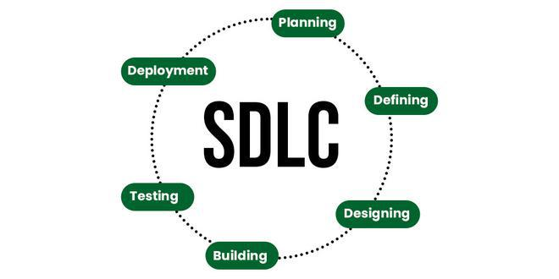

Stages of the Software Development Life Cycle
SDLC specifies the tasks to be performed at various stages by a software engineer or developer. It ensures that the end product is able to meet the customer's expectations and fits within the overall budget. Hence, it's vital for a software developer to have prior knowledge of this software development process. SDLC is a collection of these six stages, and the stages of SDLC are as follows:
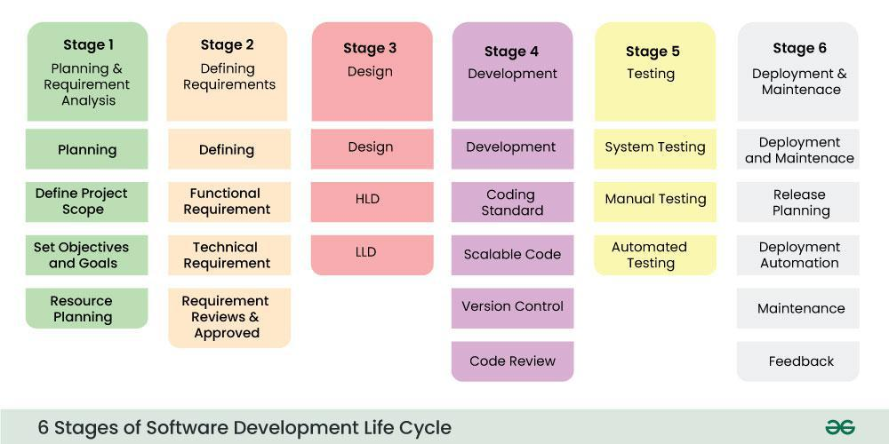Software Development Life Cycle Model SDLC Stages
The SDLC Model involves six phases or stages while developing any software.

Stage 1: Planning and Requirement Analysis
Planning is a crucial step in everything, just as in software development. In this same stage, requirement analysis is also performed by the developers of the organization. This is attained from customer inputs, and sales department/market surveys.
The information from this analysis forms the building blocks of a basic project. The quality of the project is a result of planning. Thus, in this stage, the basic project is designed with all the available information.
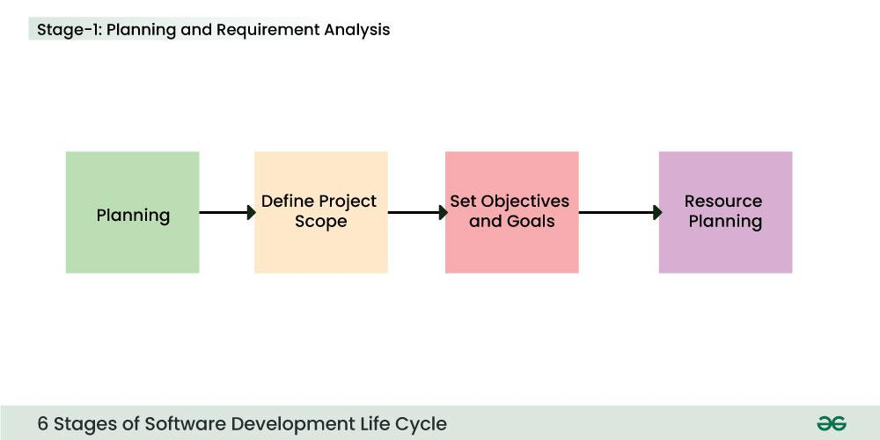Stage-1 : Planning and Requirement Analysis

Stage 2: Defining Requirements
In this stage, all the requirements for the target software are specified. These requirements get approval from customers, market analysts, and stakeholders.
This is fulfilled by utilizing SRS (Software Requirement Specification). This is a sort of document that specifies all those things that need to be defined and created during the entire project cycle.
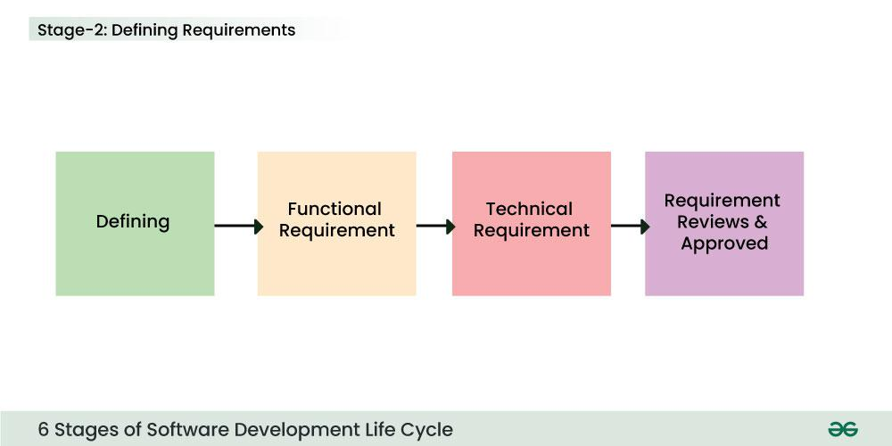Stage-2 : Defining Requirements

Stage 3: Designing Architecture
SRS is a reference for software designers to come up with the best architecture for the software. Hence, with the requirements defined in SRS, multiple designs for the product architecture are present in the Design Document Specification (DDS).
This DDS is assessed by market analysts and stakeholders. After evaluating all the possible factors, the most practical and logical design is chosen for development.
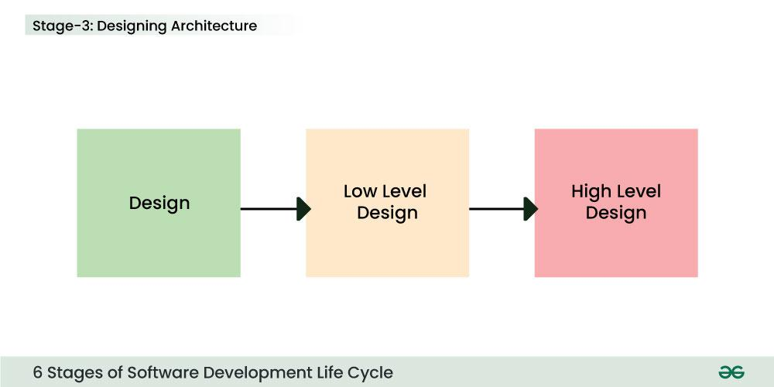Stage 3: Design

Stage 4: Developing Product
At this stage, the fundamental development of the product starts. For this, developers use a specific programming code as per the design in the DDS. Hence, it is important for the coders to follow the protocols set by the association. Conventional programming tools like compilers, interpreters, debuggers, etc. are also put into use at this stage. Some popular languages like C/C++, Python, Java, etc. are put into use as per the software regulations.
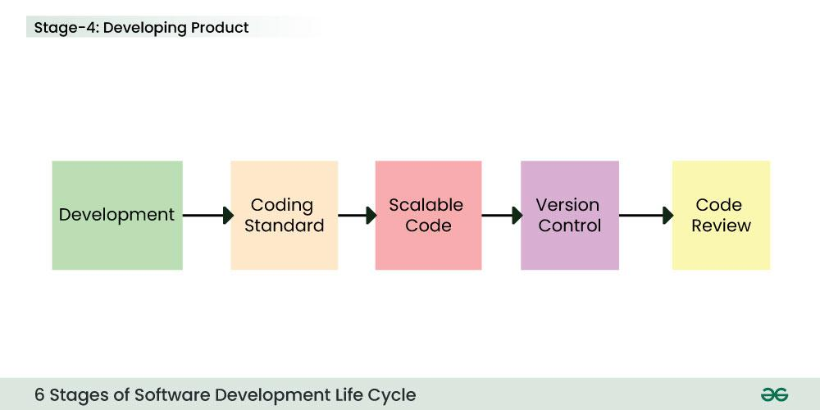Stage 4: Development

Stage 5: Product Testing and Integration
After the development of the product, testing of the software is necessary to ensure its smooth execution. Although, minimal testing is conducted at every stage of SDLC. Therefore, at this stage, all the probable flaws are tracked, fixed, and retested. This ensures that the product confronts the quality requirements of SRS.
Documentation, Training, and Support: Software documentation is an essential part of the software development life cycle. A well-written document acts as a tool and means to information repository necessary to know about software processes, functions, and maintenance. Documentation also provides information about how to use the product. Training in an attempt to improve the current or future employee performance by increasing an employee's ability to work through learning, usually by changing his attitude and developing his skills and understanding.
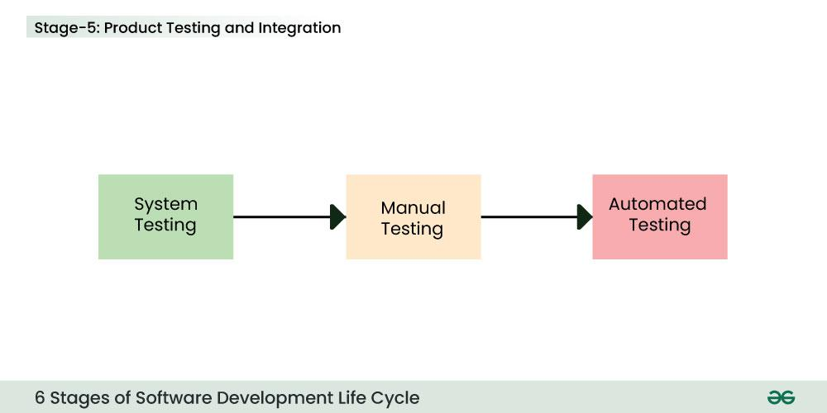Stage 5: Testing

Stage 6: Deployment and Maintenance of Products
After detailed testing, the conclusive product is released in phases as per the organization’s strategy. Then it is tested in a real industrial environment. It is important to ensure its smooth performance. If it performs well, the organization sends out the product as a whole. After retrieving beneficial feedback, the company releases it as it is or with auxiliary improvements to make it further helpful for the customers. However, this alone is not enough. Therefore, along with the deployment, the product's supervision.

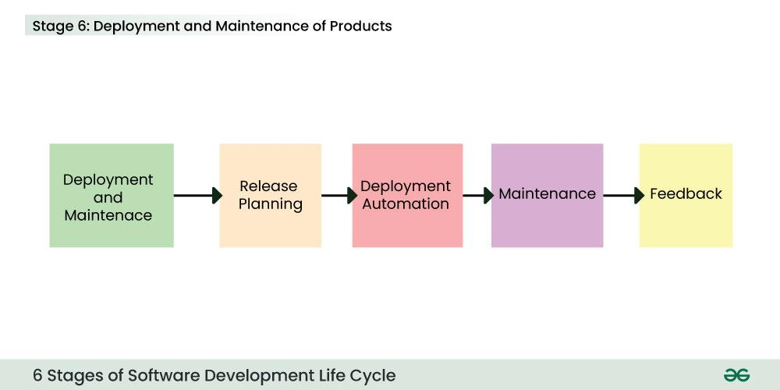Stage

TASK 1
PRESENTATION:
  - Describe software requirement specification
  - Describe design stage in software development life cycle
Group
    - Implement DFD, ERD and EERD in Data modeling
    - Implement Classical Modeling (Unified Modeling Language (UML)) and tools in Process modeling such as Sequence, activity diagrams.
  - Implement Object- Oriented Modeling and tools such as Class Diagram

  - Describe Architecture Modeling

  - Describe Interface Modeling

ASSIGNMENT
  - Describe Software development and implementation in software development life

UNIT THREE

Software Testing
Software Testing is a process of verifying and validating whether the Software Product or Application is working as expected or not. The complete testing includes identifying errors and bugs that cause future problems for the performance of an application.

Software Testing Can be Divided into Two Steps:
Software testing mainly divides into the two parts, which is used in the Software Development Process:
- Verification: This step involves checking if the software is doing what is supposed to do. Its like asking, "Are we building the product the right way?"
- Validation: This step verifies that the software actually meets the customer's needs and requirements. Its like asking, "Are we building the right product?"

Types of Software Testing
Here are the Types of Software Testing mainly categorized into the two domain, which are below.
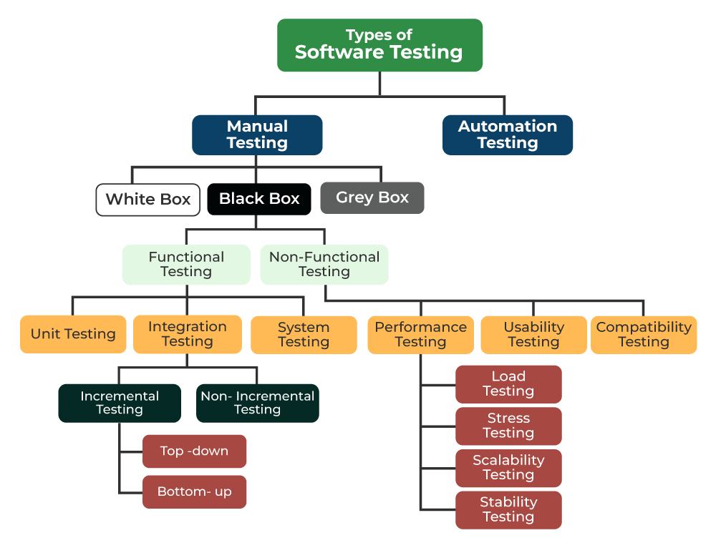

Types Software Testing

1. Manual Testing
Manual Testing is a technique to test the software that is carried out using the functions and features of an application. Which means manual testing will check the defect manually with trying one by one function is working as expected.

2. Automation Testing
Automation Testing It is a technique where the Tester writes scripts independently and uses suitable Software or Automation Tools to test the software. It is an Automation Process of a Manual Process. It allows for executing repetitive tasks without the use of a Manual Tester.

Types of Manual Testing
Manual testing will be divided into further types which is following:

1. White Box Testing
White Box Testing is a software testing technique that involves testing the internal structure and workings of a software application. The tester has access to the source code and uses this knowledge to design test cases that can verify the correctness of the software at the code level.

2. Black Box Testing
Black-Box Testing is a type of software testing in which the tester is not concerned with the internal knowledge or implementation details of the software but rather focuses on validating the functionality based on the provided specifications or requirements.

3. Gray Box Testing
Gray Box Testing is a software testing technique that is a combination of the Black Box Testing technique and the White Box Testing technique. In the Black Box Testing technique, the tester is unaware of the internal structure of the item being tested and in White Box Testing the internal structure is known to the tester.

Here is the Black Box and White and Grey Box Testing, Let’s see the differences between them.
S. No. | Black Box Testing | Gray Box Testing | White Box Testing
1. | This testing has Low granularity. | This testing has a medium level of granularity. | This testing has high-level granularity.
2. | It is done by end-users and also by the tester and developers. | It is done by end-users (called user acceptance testing) and also by testers and developers. | It is generally done by testers and developers.
3. | Here, Internals are not required to be known. | Here, Internals relevant to the testing are known. | Here, the Internal code of the application and database is known.
4. | It is likely to be less exhaustive than the other two. | It is kind of in-between. | Most exhaustive among all three.
5. | It is based on requirements, and test cases on the functional specifications, as the internals are not known. | It provides better variety/depth in test cases on account of high-level knowledge of the internals. | It can exercise code with a relevant variety of data.

Types of Black Box Testing
Black Box Testing will be divided into further types which is following:

1. Functional Testing
Functional Testing is a type of Software Testing in which the system is tested against the functional requirements and specifications. Functional testing ensures that the requirements or specifications are properly satisfied by the application.

2. Non-Functional Testing
Non-Functional Testing is a type of Software Testing that is performed to verify the non-functional requirements of the application. It verifies whether the behavior of the system is as per the requirement or not. It tests all the aspects that are not tested in functional testing.

Types of Functional Testing
Functional Testing will be divided into further types which is following:

1. Unit Testing
Unit Testing is a method of testing individual units or components of a software application. It is typically done by developers and is used to ensure that the individual units of the software are working as intended.

2. Integration Testing
Integration Testing is a method of testing how different units or components of a software application interact with each other. It is used to identify and resolve any issues that may arise when different units of the software are combined.

3. System Testing
System Testing is a type of software testing that evaluates the overall functionality and performance of a complete and fully integrated software solution. It tests if the system meets the specified requirements and if it is suitable for delivery to the end-users.

Types of Non-functional Testing
Here are the Types of Non-Functional Testing

1. Performance Testing
Performance Testing is a type of software testing that ensures software applications perform properly under their expected workload. It is a testing technique carried out to determine system performance in terms of sensitivity, reactivity, and stability under a particular workload.

2. Usability Testing
Usability Testing in software testing is a type of testing, that is done from an end user’s perspective to determine if the system is easily usable. Usability testing is generally the practice of testing how easy a design is to use on a group of representative users.

3. Compatibility Testing
Compatibility Testing is software testing that comes under the non-functional testing category, and it is performed on an application to check its compatibility (running capability) on different platforms/environments. This testing is done only when the application becomes stable.
You can learn more Software Testing Types which is included in the Software testing in detail.

Different Levels of Software Testing
In Software testing there are Different Levels of Testing can be majorly classified into 4 levels:
- Unit Testing: In this type of testing, errors are detected individually from every component or unit by individually testing the components or units of software to ensure that they are fit for use by the developers. It is the smallest testable part of the software.
- Integration Testing: In this testing, two or more modules which are unit tested are integrated to test i.e., technique interacting components, and are then verified if these integrated modules work as per the expectation or not, and interface errors are also detected.
- System Testing: In system testing, complete and integrated Software are tested i.e., all the system elements forming the system are tested as a whole to meet the requirements of the system.
- Acceptance Testing: This is a kind of testing conducted to ensure that the requirements of the users are fulfilled before its delivery and that the software works correctly in the user’s working environment.

Why is Importance of Software Testing?
Software testing is important for the several reasons and it mainly classified in the following reason which are affecting the most.
- Defects can be Identified Early: Software testing is important because if there are any bugs they can be identified early and can be fixed before the delivery of the software.
- Improves Quality of Software: Software Testing uncovers the defects in the software, and fixing them improves the quality of the software.
- Increased Customer Satisfaction: Software testing ensures reliability, security, and high performance which results in saving time, costs, and customer satisfaction.
- Helps with Scalability: Software testing type non-functional testing helps to identify the scalability issues and the point where an application might stop working.
- Saves Time and Money: After the application is launched it will be very difficult to trace and resolve the issues, as performing this activity will incur more costs and time. Thus, it is better to conduct software testing at regular intervals during software development.

Best Practices for Software Testing
Here are the best practices for software testing that help to verify the testing process:
- Continuous Testing: Project teams test each build as it becomes available thus it enables software to be validated in real environments earlier in the development cycle, reducing risks and improving the functionality and design.
- Involve Users: It is very important for the developers to involve users in the process and open-ended questions about the functionality required in the application. This will help to develop and test the software from the customer's perspective.
- Divide Tests into Smaller Parts: Dividing tests into smaller fractions save time and other resources in environments where frequent testing needs to be conducted. This also helps teams to make better analyses of the tests and the test results.
- Metrics and Reporting: Reporting enables the team members to share goals and test results. Advanced tools integrate the project metrics and present an integrated report in the dashboard that can be easily reviewed by the team members to see the overall health of the project.
- Don't Skip Regression Testing: Regression testing is one of the most important steps as it encourages the validation of the application. Thus, it should not be skipped.
- Programmers Should Avoid Writing Tests: Test cases are usually written before the start of the coding phase so it is considered a best practice for programmers to avoid writing test cases as they can be biased towards their code and the application.
- Service Virtualization: Service virtualization simulates the systems and services that are not yet developed or are missing. Thus, enabling teams to reduce dependency and start the testing process sooner. They can modify, and reuse the configuration to test different scenarios without having to alter the original environment.

Benefits of Software Testing
Here are some Benefits which give Software Testing:
- Product Quality: Testing ensures the delivery of a high-quality product as the errors are discovered and fixed early in the development cycle.
- Customer Satisfaction: Software testing aims to detect the errors or vulnerabilities in the software early in the development phase so that the detected bugs can be fixed before the delivery of the product. Usability testing is a type of software testing that checks the application for how easily usable it is for the users to use the application.
- Cost-Effective: Testing any project on time helps to save money and time for the long term. If the bugs are caught in the early phases of software testing, it costs less to fix those errors.
- Security: Security testing is a type of software testing that is focused on testing the application for security vulnerabilities from internal or external sources.

UNIT FOUR

Software Development Life Cycle (SDLC) Models
Software development models are various processes or methods that are chosen for project development depending on the objectives and goals of the project. Many development life cycle models have been developed to achieve various essential objectives. Models specify the various steps of the process and the order in which they are executed.

What is Software Modeling?
Software modeling is the process of creating abstract representations of a software system. These models serve as blueprints that guide developers, designers, and stakeholders through the system’s structure, behavior, and functionality.
By using diagrams and various modeling languages, software modeling helps in visualizing and understanding the complex aspects of the software, making it easier to plan, develop, and manage the system.

1. Waterfall Model
Waterfall Model is a famous and good version of SDLC(System Development Life Cycle) for software engineering. The waterfall model is a linear and sequential model, which means that a development phase cannot begin until the previous phase is completed. We cannot overlap phases in waterfall model.

Phases of Waterfall model
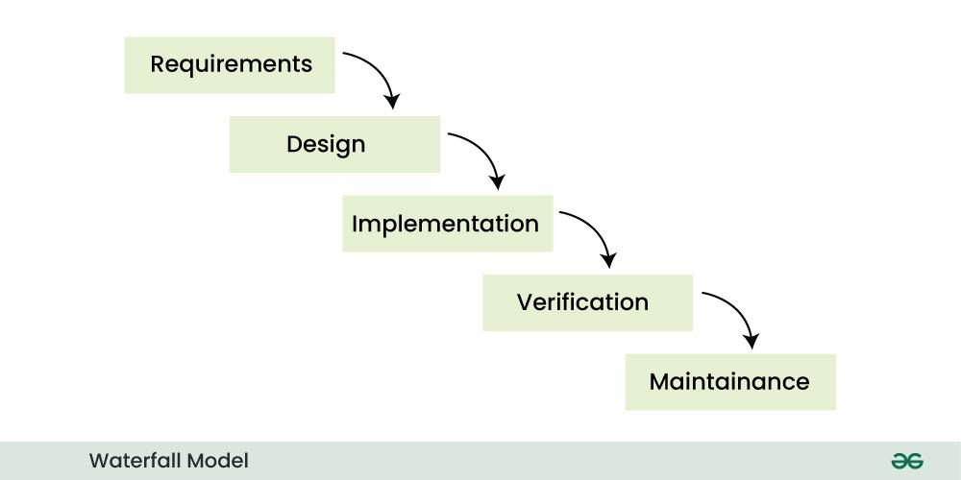
Similarly waterfall model also works, once one phase of development is completed then we move to the next phase but cannot go back to the previous phase. In the waterfall model, the output of one phase serves as the input for the other phase

1. Requirements Analysis and Specification
Requirement Analysis and specification phase aims to understand the exact requirements of the customer and document them properly. This phase consists of two different activities.
1. Requirement Gathering and Analysis: Firstly all the requirements regarding the software are gathered from the customer and then the gathered requirements are analyzed.
The goal of the analysis part is to remove incompleteness (an incomplete requirement is one in which some parts of the actual requirements have been omitted) and inconsistencies (an inconsistent requirement is one in which some part of the requirement contradicts some other part).
2. Requirement Specification: These analyzed requirements are documented in a software requirement specification (SRS) document. SRS document serves as a contract between the development team and customers. Any future dispute between the customers and the developers can be settled by examining the SRS document.

2. Design
The goal of this Software Design Phase is to convert the requirements acquired in the SRS into a format that can be coded in a programming language. It includes high-level and detailed design as well as the overall software architecture. A Software Design Document is used to document all of this effort (SDD).
- High-Level Design (HLD): This phase focuses on outlining the broad structure of the system. It highlights the key components and how they interact with each other, giving a clear overview of the system’s architecture.
- Low-Level Design (LLD): Once the high-level design is in place, this phase zooms into the details. It breaks down each component into smaller parts and provides specifics about how each part will function, guiding the actual coding process.

3. Development
In the Development Phase software design is translated into source code using any suitable programming language. Thus each designed module is coded. The unit testing phase aims to check whether each module is working properly or not.
- In this phase, developers begin writing the actual source code based on the designs created earlier.
- The goal is to transform the design into working code using the most suitable programming languages.
- Unit tests are often performed during this phase to make sure that each component functions correctly on its own.

4. Testing and Deployment
1. Testing: Integration of different modules is undertaken soon after they have been coded and unit tested. Integration of various modules is carried out incrementally over several steps. During each integration step, previously planned modules are added to the partially integrated system and the resultant system is tested. Finally, after all the modules have been successfully integrated and tested, the full working system is obtained and system testing is carried out on this. System testing consists of three different kinds of testing activities as described below.
- Alpha testing: Alpha testing is the system testing performed by the development team.
- Beta testing: Beta testing is the system testing performed by a friendly set of customers.
- Acceptance testing: After the software has been delivered, the customer performs acceptance testing to determine whether to accept the delivered software or reject it.
2. Deployment: Once the software has been thoroughly tested, it's time to deploy it to the customer or end-users. This means making the software ready and available for use, often by moving it to a live or staging environment.
During this phase, we also focus on helping users get comfortable with the software by providing training, setting up necessary environments, and ensuring everything is running smoothly. The goal is to make sure the system works as expected in real-world conditions and that users can start using it without any hitches.

5. Maintenance
In Maintenance Phase is the most important phase of a software life cycle. The effort spent on maintenance is 60% of the total effort spent to develop a full software. There are three types of maintenance.
- Corrective Maintenance: This type of maintenance is carried out to correct errors that were not discovered during the product development phase.
- Perfective Maintenance: This type of maintenance is carried out to enhance the functionalities of the system based on the customer’s request.
- Adaptive Maintenance: Adaptive maintenance is usually required for porting the software to work in a new environment such as working on a new computer platform or with a new operating system.

Features of Waterfall Model
Following are the features of the waterfall model:
- Sequential Approach: The waterfall model involves a sequential approach to software development, where each phase of the project is completed before moving on to the next one.
- Document-Driven: The waterfall model depended on documentation to ensure that the project is well-defined and the project team is working towards a clear set of goals.
- Quality Control: The waterfall model places a high emphasis on quality control and testing at each phase of the project, to ensure that the final product meets the requirements and expectations of the stakeholders.
- Rigorous Planning: The waterfall model involves a careful planning process, where the project scope, timelines, and deliverables are carefully defined and monitored throughout the project lifecycle.
Overall, the waterfall model is used in situations where there is a need for a highly structured and systematic approach to software development. It can be effective in ensuring that large, complex projects are completed on time and within budget, with a high level of quality and customer satisfaction.

Importance of Waterfall Model
Following are the importance of waterfall model:
- Clarity and Simplicity: The linear form of the Waterfall Model offers a simple and unambiguous foundation for project development.
- Clearly Defined Phases: The Waterfall Model phases each have unique inputs and outputs, guaranteeing a planned development with obvious checkpoints.
- Documentation: A focus on thorough documentation helps with software comprehension, maintenance, and future growth.
- Stability in Requirements: Suitable for projects when the requirements are clear and stable, reducing modifications as the project progresses.
- Resource Optimization: It encourages effective task-focused work without continuously changing contexts by allocating resources according to project phases.
- Relevance for Small Projects: Economical for modest projects with simple specifications and minimal complexity.

Example of Waterfall Model
Here we can take a Real world example of the Waterfall Model.
Real-Life Example of Waterfall Model: Developing an Online Banking System

1. Analysis
This phase will be tasked with gathering all the information available on customer banking requirements, transactions, security protocols, and devising the different parameters that’ll be used for determining the core functionalities of the online banking system, such as account management, fund transfers, bill payments, and loan applications.

2. Design
In this example of the Waterfall Model, the design phase is all about fine-tuning the parameters established in the analysis phase. The system’s architecture will be designed to manage sensitive data securely, avoid transactional errors, and ensure high performance. This includes database structure, user interface design, encryption protocols, and multi-factor authentication to protect user accounts.

3. Implementation
This all-important phase involves doing dummy runs of the online banking system with a provisional set of banking transactions and customer data to see the accuracy with which the system can handle transactions, balance inquiries, fund transfers, and bill payments. These results should be matched with results from banking experts and auditors who ensure compliance with banking regulations and accuracy in transactions.

4. Testing
As with any example of the Waterfall Model, the testing phase is about ensuring that all features of the online banking system function smoothly. This includes testing for security vulnerabilities, transaction accuracy, performance under heavy load, and user interface responsiveness. Special attention is given to testing secure logins, data encryption, and ensuring that sensitive data is handled correctly throughout the system.

5. Maintenance
In the final phase, the online banking system should be checked for any necessary updates or alterations that may be required, besides the expected inclusion of new features or changes in banking regulations. Regular updates will also be needed for security patches, performance improvements, and the addition of new services like mobile banking, instant loans, or personalized financial advice.

Advantages of Waterfall Model
The classical waterfall model is an idealistic model for software development. It is very simple, so it can be considered the basis for other software development life cycle models. Below are some of the major advantages of this SDLC model.
- Easy to Understand: The Classical Waterfall Model is very simple and easy to understand.
- Individual Processing: Phases in the Classical Waterfall model are processed one at a time.
- Properly Defined: In the classical waterfall model, each stage in the model is clearly defined.
- Clear Milestones: The classical Waterfall model has very clear and well-understood milestones.
- Properly Documented: Processes, actions, and results are very well documented.
- Reinforces Good Habits: The Classical Waterfall Model reinforces good habits like define-before-design and design-before-code.
- Working: Classical Waterfall Model works well for smaller projects and projects where requirements are well understood.

Disadvantages of Waterfall Model
The Classical Waterfall Model suffers from various shortcomings we can’t use it in real projects, but we use other software development lifecycle models which are based on the classical waterfall model. Below are some major drawbacks of this model.
- No Feedback Path: In the classical waterfall model evolution of software from one phase to another phase is like a waterfall. It assumes that no error is ever committed by developers during any phase. Therefore, it does not incorporate any mechanism for error correction.
- Difficult to accommodate Change Requests: This model assumes that all the customer requirements can be completely and correctly defined at the beginning of the project, but the customer's requirements keep on changing with time. It is difficult to accommodate any change requests after the requirements specification phase is complete.
- No Overlapping of Phases: This model recommends that a new phase can start only after the completion of the previous phase. But in real projects, this can't be maintained. To increase efficiency and reduce cost, phases may overlap.
- Limited Flexibility: The Waterfall Model is a rigid and linear approach to software development, which means that it is not well-suited for projects with changing or uncertain requirements. Once a phase has been completed, it is difficult to make changes or go back to a previous phase.
- Limited Stakeholder Involvement: The Waterfall Model is a structured and sequential approach, which means that stakeholders are typically involved in the early phases of the project (requirements gathering and analysis) but may not be involved in the later phases (implementation, testing, and deployment).
- Late Defect Detection: In the Waterfall Model, testing is typically done toward the end of the development process. This means that defects may not be discovered until late in the development process, which can be expensive and time-consuming to fix.
- Lengthy Development Cycle: The Waterfall Model can result in a lengthy development cycle, as each phase must be completed before moving on to the next. This can result in delays and increased costs if requirements change or new issues arise.

When to Use Waterfall Model?
Here are some cases where the use of the Waterfall Model is best suited:
- Well-understood Requirements: Before beginning development, there are precise, reliable, and thoroughly documented requirements available.
- Very Little Changes Expected: During development, very little adjustments or expansions to the project's scope are anticipated.
- Small to Medium-Sized Projects: Ideal for more manageable projects with a clear development path and little complexity.
- Predictable: Projects that are predictable, low-risk, and able to be addressed early in the development life cycle are those that have known, controllable risks.
- Regulatory Compliance is Critical: Circumstances in which paperwork is of utmost importance and stringent regulatory compliance is required.
- Client Prefers a Linear and Sequential Approach: This situation describes the client's preference for a linear and sequential approach to project development.
- Limited Resources: Projects with limited resources can benefit from a set-up strategy, which enables targeted resource allocation.
The Waterfall approach involves less user interaction in the product development process. The product can only be shown to end user when it is ready.

Applications of Waterfall Model
Here are some application of SDLC waterfall model:
- Large-scale Software Development Projects: The Waterfall Model is often used for large-scale software development projects, where a structured and sequential approach is necessary to ensure that the project is completed on time and within budget.
- Safety-Critical Systems: The Waterfall Model is often used in the development of safety-critical systems, such as aerospace or medical systems, where the consequences of errors or defects can be severe.
- Government and Defense Projects: The Waterfall Model is also commonly used in government and defense projects, where a rigorous and structured approach is necessary to ensure that the project meets all requirements and is delivered on time.
- Projects with well-defined Requirements: The Waterfall Model is best suited for projects with well-defined requirements, as the sequential nature of the model requires a clear understanding of the project objectives and scope.
- Projects with Stable Requirements: The Waterfall Model is also well-suited for projects with stable requirements, as the linear nature of the model does not allow for changes to be made once a phase has been completed.

Prototyping Model
The Prototyping Model is one of the most popularly used Software Development Life Cycle Models (SDLC models). This model is used when the customers do not know the exact project requirements beforehand.
In this model, a prototype of the end product is first developed, tested, and refined as per customer feedback repeatedly till a final acceptable prototype is achieved which forms the basis for developing the final product.
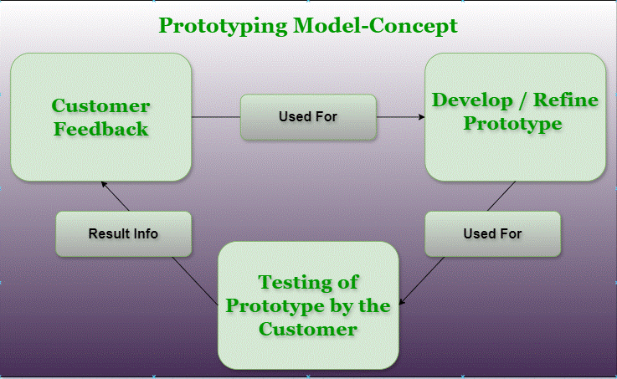Prototyping Model-Concept
In this process model, the system is partially implemented before or during the analysis phase thereby allowing the customers to see the product early in the life cycle. The process starts by interviewing the customers and developing the incomplete high-level paper model.
This document is used to build the initial prototype supporting only the basic functionality as desired by the customer. Once the customer figures out the problems, the prototype is further refined to eliminate them. The process continues until the user approves the prototype and finds the working model to be satisfactory.

Phases of Prototyping Model
Prototyping Model has six phases as follows:
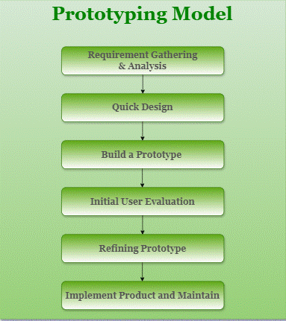
Prototyping Model Phases

1. Requirements gathering and analysis
Requirement analysis is the first step in developing a prototyping model. During this phase, the system’s desires are precisely defined. During the method, system users are interviewed to determine what they expect from the system.

2. Quick design
The second phase could consist of a preliminary design or a quick design. During this stage, the system’s basic design is formed. However, it is not a complete design. It provides the user with a quick overview of the system. The rapid design aids in the development of the prototype.

3. Build a Prototype
During this stage, an actual prototype is intended to support the knowledge gained from quick design. It is a small low-level working model of the desired system.

4. Initial user evaluation
The proposed system is presented to the client for preliminary testing at this stage. It is beneficial to investigate the performance model’s strengths and weaknesses. Customer feedback and suggestions are gathered and forwarded to the developer.

5. Refining prototype
If the user is dissatisfied with the current model, you may want to improve the type that responds to user feedback and suggestions. When the user is satisfied with the upgraded model, a final system based on the approved final type is created.

6. Implement Product and Maintain
The final system was fully tested and distributed to production after it was developed to support the original version. To reduce downtime and prevent major failures, the programmer is run on a regular basis.

Types of Prototyping Models
There are four types of Prototyping Models, which are described below.

1. Rapid Throwaway Prototyping
- This technique offers a useful method of exploring ideas and getting customer feedback for each of them.
- In this method, a developed prototype need not necessarily be a part of the accepted prototype.
- Customer feedback helps prevent unnecessary design faults and hence, the final prototype developed is of better quality.

2. Evolutionary Prototyping
- In this method, the prototype developed initially is incrementally refined based on customer feedback till it finally gets accepted.
- In comparison to Rapid Throwaway Prototyping, it offers a better approach that saves time as well as effort.
- This is because developing a prototype from scratch for every iteration of the process can sometimes be very frustrating for the developers.

3. Incremental Prototyping
- In this type of incremental prototyping, the final expected product is broken into different small pieces of prototypes and developed individually.
- In the end, when all individual pieces are properly developed, then the different prototypes are collectively merged into a single final product in their predefined order.
- It's a very efficient approach that reduces the complexity of the development process, where the goal is divided into sub-parts and each sub-part is developed individually.
- The time interval between the project's beginning and final delivery is substantially reduced because all parts of the system are prototyped and tested simultaneously.
- Of course, there might be the possibility that the pieces just do not fit together due to some lack of ness in the development phase – this can only be fixed by careful and complete plotting of the entire system before prototyping starts.

4. Extreme Prototyping
This method is mainly used for web development. It consists of three sequential independent phases:
- In this phase, a basic prototype with all the existing static pages is presented in HTML format.
- In the 2nd phase, Functional screens are made with a simulated data process using a prototype services layer.
- This is the final step where all the services are implemented and associated with the final prototype.
This Extreme Prototyping method makes the project cycling and delivery robust and fast and keeps the entire developer team focused and centralized on product deliveries rather than discovering all possible needs and specifications and adding necessitated features.

Advantages of Prototyping Model
- The customers get to see the partial product early in the life cycle. This ensures a greater level of customer satisfaction and comfort.
- New requirements can be easily accommodated as there is scope for refinement.
- Missing functionalities can be easily figured out.
- Errors can be detected much earlier thereby saving a lot of effort and cost, besides enhancing the quality of the software.
- The developed prototype can be reused by the developer for more complicated projects in the future.
- Flexibility in design.
- Early feedback from customers and stakeholders can help guide the development process and ensure that the final product meets their needs and expectations.
- Prototyping can be used to test and validate design decisions, allowing for adjustments to be made before significant resources are invested in development.
- Prototyping can help reduce the risk of project failure by identifying potential issues and addressing them early in the process.
- Prototyping can facilitate communication and collaboration among team members and stakeholders, improving overall project efficiency and effectiveness.
- Prototyping can help bridge the gap between technical and non-technical stakeholders by providing a tangible representation of the product.

Disadvantages of the Prototyping Model
- Costly concerning time as well as money.
- There may be too much variation in requirements each time the prototype is evaluated by the customer.
- Poor Documentation due to continuously changing customer requirements.
- It is very difficult for developers to accommodate all the changes demanded by the customer.
- There is uncertainty in determining the number of iterations that would be required before the prototype is finally accepted by the customer.
- After seeing an early prototype, the customers sometimes demand the actual product to be delivered soon.
- Developers in a hurry to build prototypes may end up with sub-optimal solutions.
- The customer might lose interest in the product if he/she is not satisfied with the initial prototype.
- The prototype may not be scalable to meet the future needs of the customer.
- The prototype may not accurately represent the final product due to limited functionality or incomplete features.
- The focus on prototype development may shift away from the final product, leading to delays in the development process.
- The prototype may give a false sense of completion, leading to the premature release of the product.
- The prototype may not consider technical feasibility and scalability issues that can arise during the final product development.
- The prototype may be developed using different tools and technologies, leading to additional training and maintenance costs.
- The prototype may not reflect the actual business requirements of the customer, leading to dissatisfaction with the final product.

Applications of Prototyping Model
- The Prototyping Model should be used when the requirements of the product are not clearly understood or are unstable.
- The prototyping model can also be used if requirements are changing quickly.
- This model can be successfully used for developing user interfaces, high-technology software-intensive systems, and systems with complex algorithms and interfaces.
- The prototyping Model is also a very good choice to demonstrate the technical feasibility of the product.

Agile Development Model
The Agile Model was primarily designed to help a project adapt quickly to change requests. So, the main aim of the Agile model is to facilitate quick project completion. To accomplish this task, it's important that agility is required. Agility is achieved by fitting the process to the project and removing activities that may not be essential for a specific project.

Steps in the Agile Model
The Agile Model is a combination of iterative and incremental process models. The phases involve in Agile (SDLC) Model are:
- Requirement Gathering
- Design the Requirements
- Construction / Iteration
- Testing / Quality Assurance
- Deployment
- Feedback

1. Requirement Gathering
In this step, the development team must gather the requirements, by interaction with the customer. development team should plan the time and effort needed to build the project. Based on this information you can evaluate technical and economical feasibility.
- Meet with the customer to really understand their needs and what they expect from the software.
- Identify the key requirements and business goals to make sure everyone is on the same page.
- Estimate how much time and effort it will take to develop the software.
- Assess if the project is technically possible and whether it's worth the investment from both a technical and economic standpoint.

2. Design the Requirements
In this step, the development team will use user-flow-diagram or high-level UML Diagrams to show the working of the new features and show how they will apply to the existing software. Wireframing and designing user interfaces are done in this phase.
- Designing the system: Once the requirements are gathered, the next step is to design the system’s overall architecture based on those needs. This helps to verify the software is structured in a way that meets the user’s expectations.
- Creating wireframes: Next, wireframes for the user interface (UI) are created. These are simple blueprints that show how the software will look and how users will interact with it, ensuring it’s user-friendly and easy to navigate.
- High-level design with UML diagrams: At this stage, high-level designs using UML (Unified Modeling Language) diagrams are created to visually represent the software’s structure and how different parts will work together.
- Prototyping for feedback: Prototypes are made to give stakeholders an early look at the software. This helps gather feedback early in the process and allows for adjustments before the full development begins.

3. Construction / Iteration
In this step, development team members start working on their project, which aims to deploy a working product. Each cycle typically consist between 1-4 weeks, and at the end, the team delivers a working version of the software.
- Development of Features: The team works on the features identified during the requirement and design phases.
- Coding and Implementation: New functionalities are coded and integrated into the software based on the goals for that specific iteration.
- Delivering a Working Product: After each iteration, a usable version of the software is ready.
- Incremental Improvement: With every cycle, the software is enhanced, adding more features and refining existing ones.

4. Testing / Quality Assurance
Testing involves Unit Testing, Integration Testing, and System Testing, Which help in the agile development models:
- Unit Testing: Unit testing is the process of checking small pieces of code to ensure that the individual parts of a program work properly on their own. Unit testing is used to test individual blocks (units) of code.
- Integration Testing: Integration testing is used to identify and resolve any issues that may arise when different units of the software are combined.
- System Testing: Goal is to ensure that the software meets the requirements of the users and that it works correctly in all possible scenarios.

5. Deployment
In this step, the development team will deploy the working project to end users.
Once an iteration is finished and fully tested, the software is ready to be released to the end users. In Agile, deployment isn't a one-time event—it's an ongoing process. Updates and improvements are rolled out regularly, making sure the software keeps evolving and getting better with each release.
- Deploy the software to a test or live environment so that it can be used by customers or end-users.
- Make the software accessible to users, verifying they can start using it as expected.
- Verify the deployment goes smoothly and fix any issues that come up quickly

6. Feedback
This is the last step of the Agile Model. In this, the team receives feedback about the product and works on correcting bugs based on feedback provided by the customer.
- Take feedback from customers, users, and stakeholders after each iteration.
- Understand how well the product meets user needs and identify areas for improvement.
- Check for bugs or issues that need fixing.
- Make adjustments to the development plan based on feedback to improve the product further.

Agile SDLC Methods
Some of the Agile Testing Methodologies are:
- Test-Driven Development (TDD): TDD is the software development process relying on creating unit test cases before developing the actual code of the software. It is an iterative approach that combines 3 operations, programming, creation of unit tests, and refactoring.
- Behavior Driven Development (BDD): BDD is agile software testing that aims to document and develop the application around the user behavior a user expects to experience when interacting with the application. It encourages collaboration among the developer, quality experts, and customer representatives.
- Exploratory Testing: In exploratory testing, the tester has the freedom to explore the code and create effective and efficient software. It helps to discover the unknown risks and explore each aspect of the software functionality.
- Acceptance Test-Driven Development (ATDD): ATDD is a collaborative process where customer representatives, developers, and testers come together to discuss the requirements, and potential pitfalls and thus reduce the chance of errors before coding begins.
- Extreme Programming (XP): Extreme programming is a customer-oriented methodology that helps to deliver a good quality product that meets customer expectations and requirements.
- Session-Based Testing: It is a structured and time-based approach that involves the progress of exploratory testing in multiple sessions. This involves uninterrupted testing sessions that are time-boxed with a duration varying from 45 to 90 minutes. During the session, the tester creates a document called a charter document that includes various information about their testing.
- Dynamic Software Development Method (DSDM): DSDM is an agile project delivery framework that provides a framework for building and maintaining systems. It can be used by users, developers, and testers.
- Crystal Methodologies: This methodology focuses on people and their interactions when working on the project instead of processes and tools. The suitability of the crystal method depends on three dimensions, team size, criticality, and priority of the project.

Characteristics of the Agile Process
The Agile process is all about being flexible, working together, and focusing on delivering real value to customers. Here is the Characteristics of the Agile Process:
- Agile processes must be adaptable to technical and environmental changes. That means if any technological changes occur, then the agile process must accommodate them.
- The development of agile processes must be incremental. That means, in each development, the increment should contain some functionality that can be tested and verified by the customer.
- The customer feedback must be used to create the next increment of the process.
- The software increment must be delivered in a short span of time.
- It must be iterative so that each increment can be evaluated regularly.

When To Use the Agile Model?
The Agile model works really well for certain types of projects. Here’s when Use the Agile Model:
- When new changes need to be implemented. The freedom that playfulness gives for change is very important.
- New changes can be implemented at a very low cost due to the frequency of new increments.
- Implementing a new feature requires developers to lose only a few days or even just hours of work to get it back and implemented.
- In the Agile model, unlike the Waterfall model, very limited planning is required to start a project.
- Agile believes that the needs of end users are always changing in the dynamic business and IT world.
- Changes can be discussed and features can be redesigned or removed based on feedback.

Advantages of the Agile Model
- Working through Pair programming produces well-written compact programs which have fewer errors as compared to programmers working alone.
- It reduces the total development time of the whole project.
- Agile development emphasizes face-to-face communication among team members, leading to better collaboration and understanding of project goals.
- Customer representatives get the idea of updated software products after each iteration. So, it is easy for him to change any requirement if needed.
- Agile development puts the customer at the center of the development process, ensuring that the end product meets their needs.

Disadvantages of the Agile Model
- The lack of formal documents creates confusion and important decisions taken during different phases can be misinterpreted at any time by different team members.
- It is not suitable for handling complex dependencies.
- The agile model depends highly on customer interactions so if the customer is not clear, then the development team can be driven in the wrong direction.
- Agile development models often involve working in short sprints, which can make it difficult to plan and forecast project timelines and deliverables. This can lead to delays in the project and can make it difficult to accurately estimate the costs and resources needed for the project.
- Agile development models require a high degree of expertise from team members, as they need to be able to adapt to changing requirements and work in an iterative environment. This can be challenging for teams that are not experienced in agile development practices and can lead to delays and difficulties in the project.
- Due to the absence of proper documentation, when the project completes and the developers are assigned to another project, maintenance of the developed project can become a problem.

TASK
PRESENTATION
- Describe Software project management and cost estimation in software project planning
- Software Quality control and assurance during software project implementation
ASSIGNMENT
- Discuss software risk management techniques in software engineering

